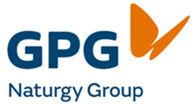

GPG Naturgy Group
Community Grants 2026/27

Application Form



1. APPLICANT DETAILS:
Name of Applicant (Group of Committee):
Contact Person:
Street Address:
Postal Address:
Email:
Mobile Phone: |  | Is the organisation registered for GST?
Is the applicant an incorporated organisation? |  | ABN (if applicable):

2. BANK DETAILS
Account Name:
BSB: |  | Account No.

3. PROJECT DETAILS
Project Title:
Project Details:
(Provide a full description of what your project entails)

4. PROJECT DETAILS (add extra lines if necessary)
Community Benefit
What It Means: How will the project help the local community?
Questions to Ask: Who will benefit from this? Does it address important community needs? Will it improve the well-being of the community? Why is this project needed?
Realistic and Lasting
What It Means: Is the project achievable and realistic – will it be able to delivered within the timeframe and budget.
Questions to Ask: Is the plan clear and within budget? Can the project continue to benefit the community after the funding ends? Is the project able to be completed on time?
Community Involvement
What It Means: Does the project bring people together and involve the community?
Questions to Ask: Does it encourage partnerships or teamwork? How will the community be involved in making it happen?

5. BUDGET
Please note that for all expense items above $500, you need to attach a copy of the quote. (All values in the budget table are to be excluding GST)
Budget amount $
(excl. GST)
Income
Cunderdin Community Grant request <enter grant request amount>
Your Organisation’s monetary contribution
Other Income <Insert description>
Other Income <Insert description>
Total Income
Expenses
Expense item
Expense item
Expense item
Total Expenses (excl. GST)
Surplus/(Deficit) | -
Total In-kind Support <estimated dollar value>

<explain how in-kind support is calculated>
Please estimate the dollar value of any donations of goods or services as the in-kind support (e.g. volunteer hours, free food etc.). Volunteer hours are to utilise a standard value of $25/hr.
Add additional rows where required

6. CHECKLIST
Please check your application carefully and ensure all relevant information has been provided. Additional supporting documentation can be attached to the application and provide comments if items on checklist are not met.
Item | Yes | No | Comment
Have you discussed your project with the Community Development Officer?
Have you completed all sections of the application form?
Is a copy of the Certificate of Incorporation attached (where relevant)?
Is a copy of Public Liability Insurance attached?
Is a copy of a recent Financial Statement (or similar) attached?
Are copies of quote for items above $500 attached?
Are all additional supporting documents attached? E.g. letters of support, project plan etc.
Has the application been endorsed by the organisation’s committee? Attach evidence where possible.

7. DECLARATION
I hereby certify that I have been authorised to prepare and submit this application, and that the information herein is, to the best of my knowledge true and correct.

Should financial assistance be provided by the Shire of Cunderdin, the applicant agrees to the following conditions of funding:
- The financial contribution from the Shire of Cunderdin is not retrospective - funding will not be provided if the event/project commences prior to Shire approval.
- The financial assistance will be used only for the purposes for which it is granted, unless otherwise agreed in writing by the Shire of Cunderdin.
- The Shire of Cunderdin will be advised of any change in scope of the project and the Shire of Cunderdin retains the right to refuse/reduce its level of financial assistance in that instance.
- Funding will be expended on the latest by 31 May 2027.
- Unspent funds are to be returned to the Shire of Cunderdin within 3 months of event/project date/end of grant term.
- If special conditions are applied as a condition of funding, the applicant will be required to agree in writing to these conditions prior to the financial assistance being provided.
- The applicant will acknowledge the GPG Naturgy Group support in all public communications relating to the event/project, including signage, advertising and promotional materials in accordance with Shire requirements.
- The applicant will provide a full acquittal of all funds, including project evaluation and evidentiary materials as required by the Shire of Cunderdin within three months of the end of the grant term.

Full Name: |  | Signature:
Position held: |  | Date:
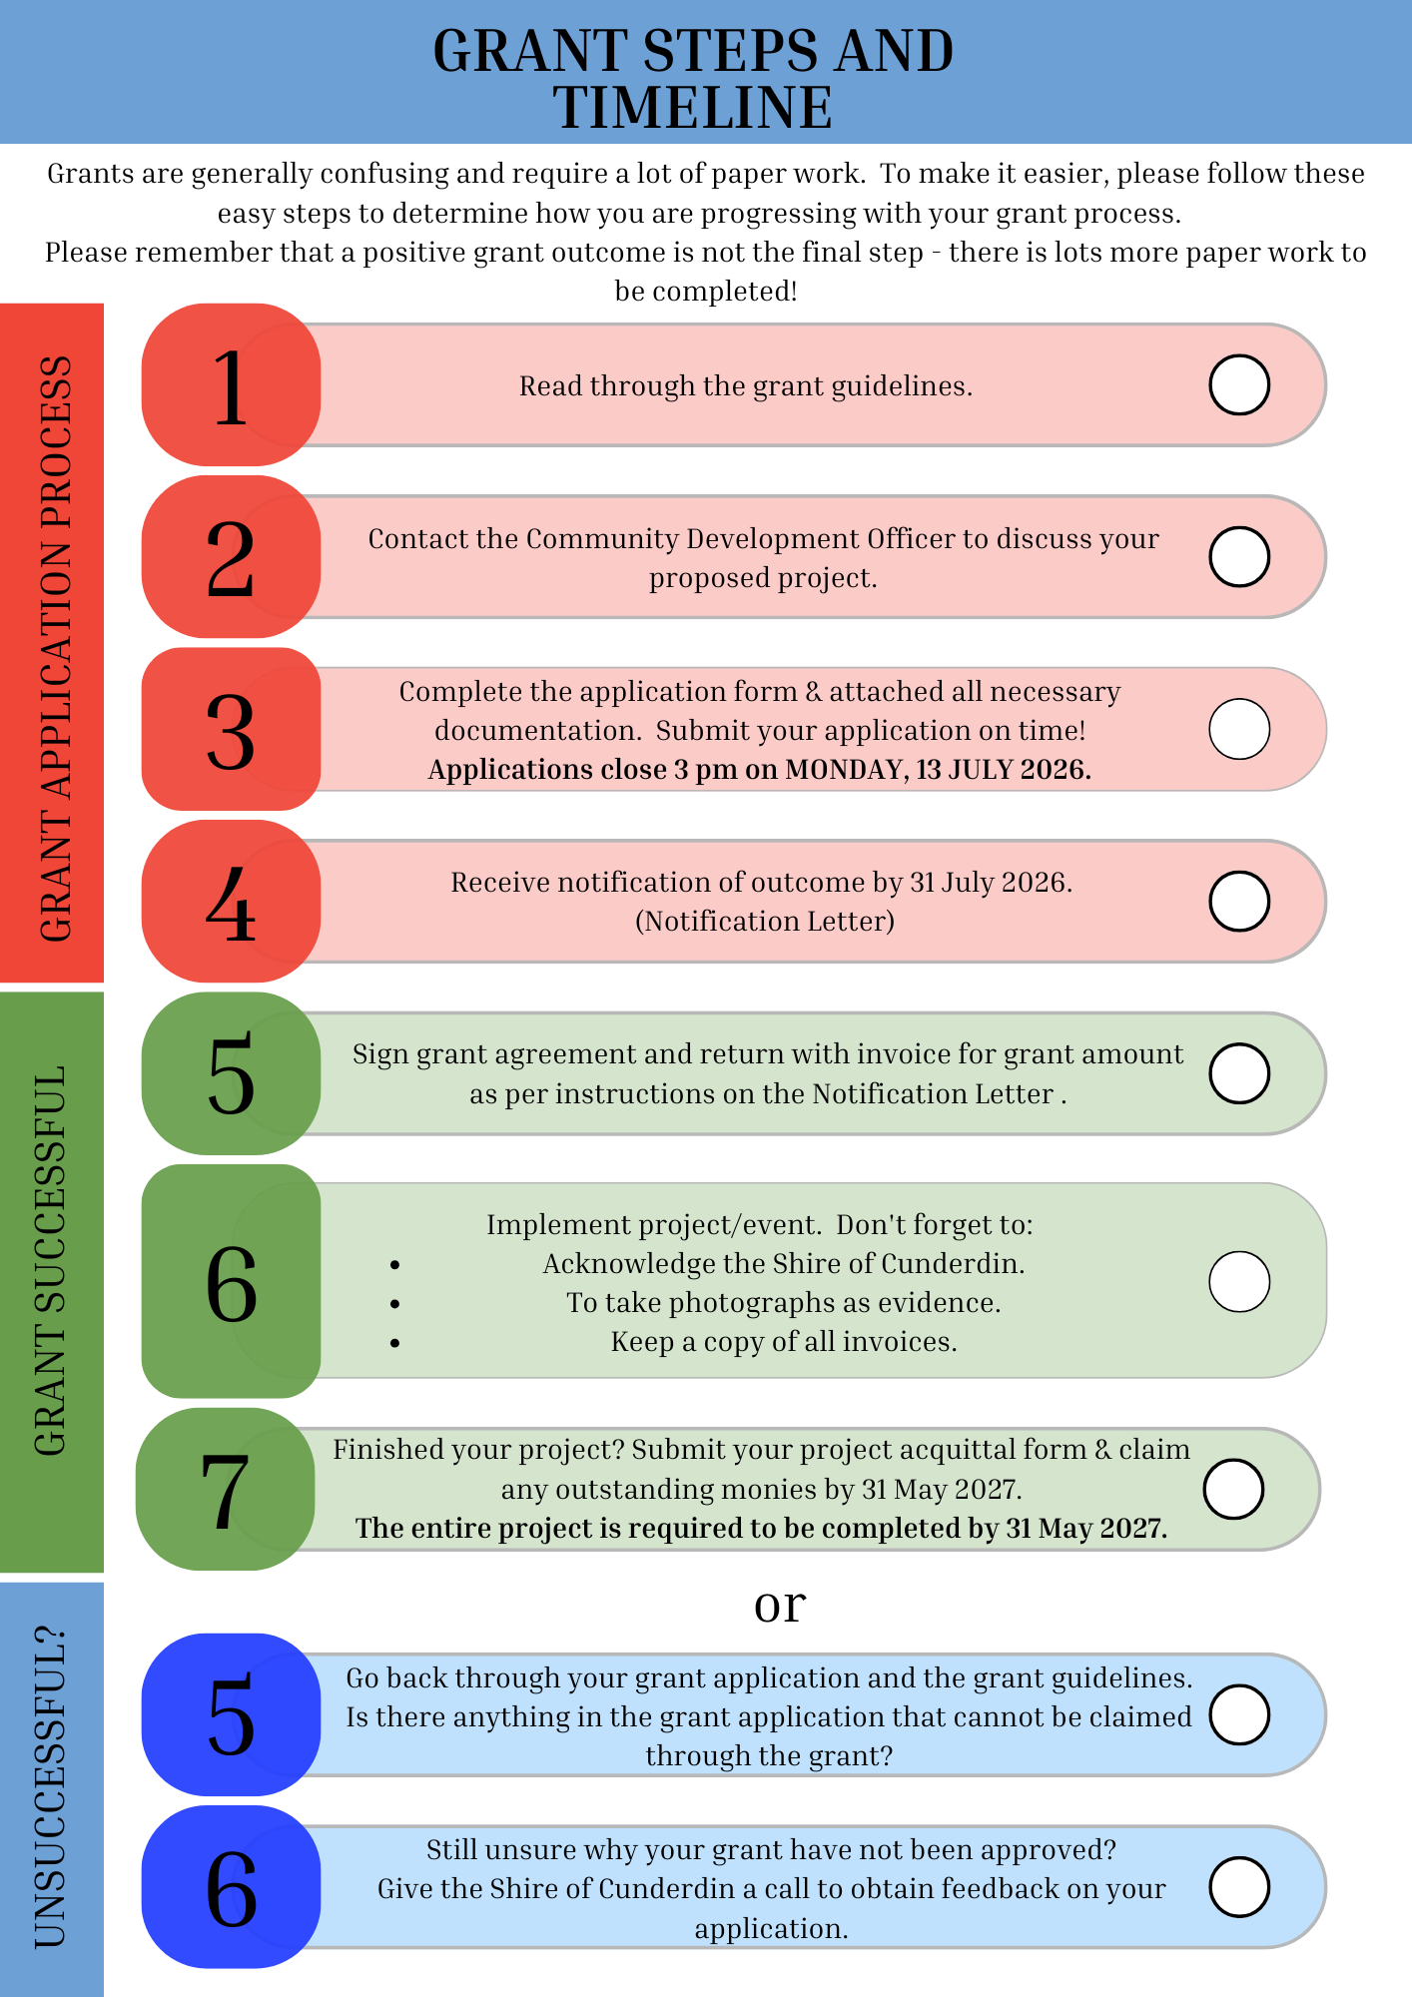

Attachments:
Please place any attachments at the back of your application.

