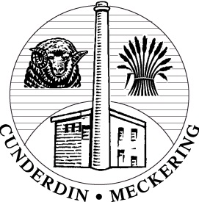
Shire of Cunderdin
Incorporating the districts of Cunderdin and Meckering

P.O. Box 100 Cunderdin Western Australia 6407
Tel: (08) 9635 2700 Fax: (08) 9635 1464
Email: admin@cunderdin.wa.gov.au

Application for Clearance of Subdivision Approval
Property Details:

Lot No: | Original House No: |  | Street Address: |  | Suburb:
Date of Approval: |  | WAPC Reference No: |  | Deposited Plan Number:
Conditions Numbered: (for Shire Clearance)

Number of lots on Deposited Plan: |  |  | Clearance Application Fees: (incl. common property and balance lots)
Contact Person Details:

Name: |  |  | Company:
Address:

Email: |  | Phone: |  | Fax:

Applications must include a separate cheque for clearance application fees.
Lodgement checklist and Conditions form must be completed with all certifications; anything left incomplete or not included in the application will result in the application being returned.
Copies of all relevant documentation and supporting evidence / reports are to be provided with each application regardless of having been previously provided to the Shire for other reasons or as part of a previous clearance request.

Application for Clearance of Conditions Checklist
All Shire Conditions must be satisfied and certification documents attached for the clearance process to begin
Condition No. | Condition Keywords | Provide comment AND evidence (copies of reports, Statutory Declarations, Plans etc) as to how each condition has been fulfilled (Must be completed)
i.e. 6 | i.e. Crossovers | i.e. Crossovers constructed to Shire specifications
I declare that all conditions have been satisfied and I understand anything left incomplete will result in the application unable to be processed and the application being returned.
Signed: _____________________
Name & Position: ______________________________________

