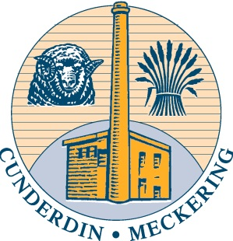

Are you interested in becoming a Cunderdin Shire Councillor?

Would you like to know more about representing your community, local government and the responsibilities of being a Councillor?

Local Government Elections will be held on Saturday 19 October 2013.

There will be five (5) vacancies in the district of the Cunderdin Shire:
- Four (4) vacancies for four (4) year terms
- One (1) vacancy for two (2) year term

If you are thinking of nominating for Council, please contact the undersigned on 9635 1005 to arrange for an informal information session to have a chat and ask questions!

Please note that nominations will open on Thursday 5th September 2013, and close at 4:00pm on Thursday 12th September 2013.

Peter Naylor
Chief Executive Officer

